How Artificial Intelligence is used for Business Process Improvement (BPI)

Nowadays, the main goal of businesses is to be as fast as possible, without compromising on quality and at a low cost. To achieve this, they have to find the best processes by analyzing a lot of datasets that we call "**event logs**." These event logs are essentially a journal of events about business process evolutions. This methodology is known as Process Mining.

Basically, Process Mining is used to discover, monitor, and improve real processes by extracting knowledge from real event logs. Process mining techniques enable organizations to visualize, analyze, and optimize their business processes based on actual event data rather than subjective assessments or hypothetical models.

To understand how the new processes are created, these event logs are linked to create a **Recurrent Neural Network (RNN)**: basically, each input is analyzed individually, and each analysis is based on the previous one. To enhance this method, we add a **Long Short-Term Memory (LSTM)** to this neural network so that it can learn long-term dependencies. Finally, a **Bidirectional LSTM (BLSTM)** is created to capture information from both the past and future context.

In the end, to have a clear understanding of all of this, a graph is drawn in three parts :

* First, a graph with all the event logs
* Then, a new system is proposed as a candidate to correct and improve all the conflicts or problems that occurred based on the previous data by using a **Petri net.**

A Petri net is used to model a variety of systems. It allows for the analysis of system dynamics, detection of blockages, conflicts, and performance issues, as well as verification of system behavior feasibility and correctness. They are widely used in the field of computer science for the design and analysis of concurrent and parallel systems.

The advantages and risks of using Artificial Intelligence (AI) in Process Mining (PM)

**Process Mining** is used to discover, monitor, and improve real processes by extracting knowledge from real event logs. Process mining techniques enable organizations to visualize, analyze, and optimize their business processes based on actual event data rather than subjective assessments or hypothetical models. AI can be used in all kinds of fields: for example, in the food sector by regulating the temperature of the ovens or in the medical field to improve their management.

Talking about the medical field, we more specifically talk about **Process Mining in Organization (PMO)**. It also combines **Business Process Modeling (BPM)** to represent the new system through a graph.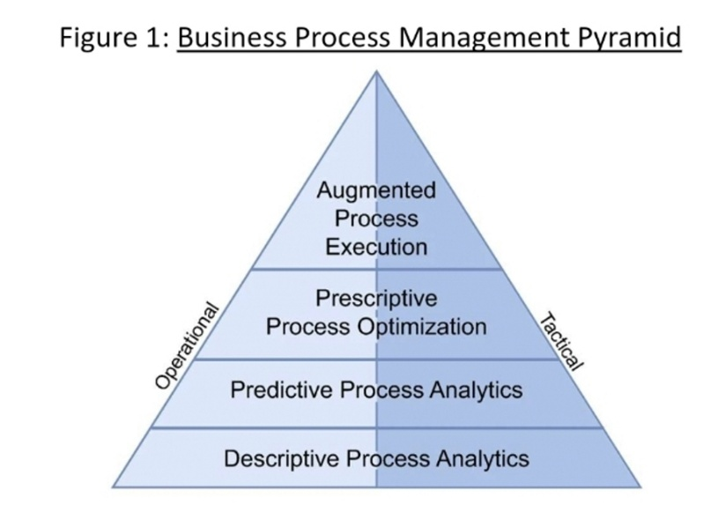

The BPM is a pyramid with 4 layers :

* At the bottom, you describe the current processes of your business.
* Then, you predict the processes for the upcoming years.
* The third layer takes all those predictions to take action in order to improve our business.
* The last layer automates everything, and all is supervised by people.

But we should be careful with the use of AI, this is why a lot of country want to regulate everything surrounding it. For instance we talk about **Responsible Data Science (RDS).** It refers to the ethical and conscientious use of data science techniques, tools, and methodologies to ensure that data-driven decision-making processes are fair, transparent, and respectful of privacy, security, and societal values.

Process Mining : The adaptation of the AI

Although AI is bringing a huge improvement in PM, there is one main problem: it can only predict systems based on **previous data**, meaning it can’t predict scenarios that **haven’t already occurred**. This is why an algorithm has been developed as an adjustment to business processes. It’s a **three-step goal heuristic algorithm**, meaning it’s not the most optimal system but a satisfying one. First, it processes mined existing processes, then applies a heuristic system and evaluates the comparison of these processes, without forgetting to take into account the new goal scenarios and objectives wanted by the company.

But how to know if the new process will succeed or fail?

**The Apriori system** is an algorithm used in the field of data mining to extract association rules from transactional databases. It works by identifying sets of items that frequently appear together in transactions and using this information to generate association rules. The algorithm is based on the principles of support and confidence, where support measures the frequency with which a set of elements appear together, and confidence measures the conditional probability that certain elements appear together. It uses **three measures of success**: model quality, process efficiency, and process impact, and **five success factors**: structured approach to process mining, quality of data, management support, process mining expertise, and personal skill.

Since it will be more practical to be able to find an optimal process that could work in any field, **General Systems Theory (GST)** has been study. It means to identify common principles and patterns that apply to different types of systems, whether biological, social, or technological. Rather than analyzing them separately, it seeks to find concepts and theories that are applicable to a wide range of systems, regardless of their specific domain. This helps develop a more holistic and integrated understanding of complex systems.

To illustrate this adaptivity, Process Mining has been used in the education field (**Learn Health System** or LHS) to upgrade student planning and assist curriculum designers with educational follow-up.

**Leveraging BPM and Process Mining for Business Improvement**

Business Process Management (BPM) now predicts future business process outcomes using process mining techniques. The framework enables real-time outcome prediction, leveraging process discovery and conformance analysis to extract key features from process logs. Machine learning algorithms like Naive Bayes, Logistic Regression, Random Forest, and Support Vector Machine are then applied to train and predict future outcomes. Experimental results demonstrate high accuracy and effectiveness, validated through comparative analysis. A real-world case study at BT, a major UK telecommunications firm, showcases the framework's applicability and performance in predicting process outcomes using a dataset of completed cases.

BPM methodologies and process mining techniques to enhance efficiency in e-commerce. It proposes analyzing web clickstream data to extract insights for optimizing business processes. By employing the Business Process Insight (BPI) platform, process mining algorithms are utilized to derive structured models of user behavior. These techniques aim to transform web clicks into tasks, mine business processes, and evaluate their effectiveness, ultimately contributing to improved e-commerce operations.

Process Mining, when combined with Business Intelligence & Analytics (BI&A) and Business Process Intelligence (BPI), drives value creation and enhances organizational performance. Drawing from a qualitative study involving stakeholders from eight international companies, it identifies four key aspects of process mining: end-to-end process visualization and performance metrics, sense-making of process-related data, data-driven decision making, and intervention implementation. Process mining contributes to value realization by optimizing process efficiency, resulting in both monetary gains and non-monetary benefits such as heightened customer satisfaction. It underscores the importance of comprehending technical capabilities and organizational context in adopting and deploying process mining. Additionally, it underscores process mining's role in deepening understanding of business processes for strategic decision-making and operational enhancements, offering guidance to organizations considering its implementation.

The integration of AI and ML techniques with Process Mining (PM) aims to enhance business process understanding and optimization. It addresses challenges such as data distribution mismatch, concurrency, non-stationary behavior, and data encoding, proposing solutions and future directions. Key contributions include guidelines for data representation selection, handling non-Gaussian distributions, and utilizing zero-shot learning techniques like language models. It emphasizes early quality assurance, leveraging domain knowledge, and evaluating model interpretability. Various ML models are proposed, including supervised and unsupervised learning approaches, Active Learning, and Generative Adversarial Networks (GANs). These approaches aim to improve process mining activities by addressing data representation, concept drift management, and continuous model monitoring and updating.